Software Requirement Specifications
EduMart – Your Digital Campus Shopping Platform



Submitted by
Junaid Hafeez
Roll Nunber
F22BINFT1M01224

Submitted to
Ms.Kainat

Department of Information Technology
Faculty of Computing
The Islamia University of Bahawalpur

Summery
EduMart is a web-based academic marketplace designed specifically for students and teachers, allowing them to conveniently purchase, upload, and manage educational products and materials. The SRS document defines the complete functional and non-functional requirements that guide development and ensure accurate implementation. The system will be developed using the MERN Stack, which offers scalability, a modern interface, and efficient data handling. Registered users will be able to browse categorized academic products, apply search and filtering options, add items to the cart, and place simulated checkout orders.
The platform allows users to maintain personal profiles, view their order history, and upload educational items with pricing and descriptive details. Administrators will oversee the system through a secure dashboard, enabling them to approve product listings, manage users, and monitor orders and activities. Security is ensured through encrypted passwords, role-based access control, and strict input validation.
The user interface is designed to be responsive, intuitive, and suitable even for non-technical users. Performance targets include quick loading time, reliable data access, and support for multiple simultaneous users. Although payment gateways are not included initially, they are planned as future enhancements. Other expected improvements include mobile applications, delivery tracking, user feedback modules, and advanced product recommendations.
Overall, the SRS provides a clear foundation for structured development, enabling stakeholders to align expectations, reduce ambiguity, and support future extendibility of the EduMart platform.

Table of Contents
1. Introduction 4
1.1. Purpose 4
1.2. Scope 4
1.3. Definitions,Acronyms,Abbrevitions 5

2. Overall Description 11
2.1. product prespective 12
2.2 Product Functions……………………………………………………………………………
2.3 User Characteristics…………………………………………………………………………
2.4 Constraints………………………………………………………………………………………
2.5 Assumptions and dependencies……………………………………………………………

3 Functional Requirements…………………………………………………………………………
3.1 User module……………………………………………………………………………………..
3.2 Admin Module…………………………………………………………………………………...

4. Non-Functional Requirements……………………………………………………………………
4.1 Performance Requirements…………….
4.2 Security Requirements………………......
4.3 Usability Requirements……………………
4.4 Reliability…………………………………….
4.5 Maintainability………………………………..

5. System Requirements………………………………………………………………………………..
5.1 Hardware…………………………………..
5.2 Software……………………………………

6. Technology Stack…………………………………………………………………………………….
7. Use Case Descriptions………………………………………………………………………………
8. Future Enhancements……………………………………………………………………………….
9. Conclusion……………………………………………………………………………………………

- Introduction
  - Purpose

The purpose of this Software Requirements Specification is to present a comprehensive and formal description of the EduMart system and its operational requirements. This document ensures that all stakeholders, including developers, academic supervisors, and end-users, share a unified understanding of the system’s objectives. The SRS serves as a contractual baseline that minimizes ambiguity during development and enables accurate project planning.

It defines the functional scope of EduMart, outlines expected system behavior, and specifies constraints that must be followed throughout implementation. The purpose is also to provide clarity regarding data flow, user interaction, and system architecture to support effective decision-making. This document will guide developers in adhering to academic, technical, and performance standards while ensuring that system deliverables match stated expectations.

Additionally, the SRS assists in risk identification and helps avoid requirement-related conflicts as development progresses. It serves as a reference document for future enhancements, testing procedures, maintenance activities, and evaluation criteria. Ultimately, this SRS ensures that EduMart is developed in a structured, measurable, and stakeholder-aligned manner.
  - Scope
The scope of EduMart includes the development of a digital marketplace designed specifically for academic communities, enabling students and teachers to buy, sell, and manage educational products online. The system will provide product browsing, uploading, and simulated purchasing features in a secure and user-friendly environment. EduMart will implement core functionalities such as authentication, cart management, product listing, and order tracking. The platform is limited to web-based deployment in its initial version, with future scalability considered. Additionally, it aims to centralize academic resources and streamline access to necessary study materials.
1. Academic Marketplace Functionality
EduMart will operate as an exclusive e-marketplace for academic materials including books, notes, stationery, and learning resources. Users will be able to browse categorized products with detailed descriptions, pricing, and availability. The system ensures that only educational-oriented listings are maintained, aligning with its academic objective.
2. User Interaction and Account Management
The system allows students and teachers to register, log in, and maintain personal profiles. Users can manage their uploaded products and track purchasing activities in a structured interface. Account interaction will be secured and validated to ensure authentic user participation.
3. Product Uploading and Approval Workflow
Users may upload their academic products with descriptions, images, and pricing details. Newly uploaded products will be subject to verification or approval by the administrator to ensure content authenticity. This controlled upload mechanism maintains quality, relevance, and platform integrity.
4. Order Placement and Tracking
The system supports simulated checkout, order confirmation, and tracking features. Users will receive order summaries and can view historical transactions. While real payment gateways are excluded initially, the order management structure prepares the system for future integration
5. Administrative Monitoring and Platform Governance
The platform includes an administrative module through which the admin can approve listings, manage users, and maintain system policies. Admin can track activities, evaluate order records, and remove inappropriate content. This administrative oversight ensures smooth operations and compliance with platform guidelines.
1.3 Definitions, Acronyms, Abbreviations
User:
Student or teacher who interacts with the system to browse, buy, or sell products.
Admin:
System controller who verifies users, manages products, handles complaints, and oversees platform rules.
MERN Stack:
MongoDB (Database),
Express.js (Backend framework),
React.js (Frontend library),
Node.js (Server environment).
Product Listing:
A feature allowing users to upload items they want to sell.
Checkout:
Process of confirming and placing an order.
Order Management:
Tracking and storing all purchase details.
2. Overall Description
2.1 Product Perspective

EduMart is an independent, web-based application designed from scratch rather than a modification of existing software. It functions as a single-page application (SPA), ensuring fast navigation and smooth user experience.
The platform follows a client-server architecture where:
The client-side (React.js) handles user interface, routing, and rendering.
The server-side (Node.js + Express.js) manages business logic, security, and API endpoints.
The database (MongoDB) stores product data, user accounts, order history, and system logs.
The product emphasizes modularity, maintainability, and ease of future upgrades.

2.2 Product Functions
EduMart provides the following major features:
User authentication (login/registration)
Searching, browsing, and filtering products
Adding items to shopping cart
Placing orders with confirmation
Viewing order history and product details
Uploading and managing product listings
Admin control over user accounts and product inventory
Admin ability to monitor platform activity
Secure data storage and validation
Each function is designed to support hundreds of users simultaneously while maintaining performance and accuracy.

2.3 User Characteristics
There are three main user categories:
Admin
Must have basic technical skills
Responsible for approving products, removing inappropriate content, and handling system stability
Students
Primary buyers and sellers
Use the system frequently for academic needs
Expect a simple, fast interface
Teachers
May buy academic items or upload teaching materials
Require a reliable system with accurate product categories and data integrity
None of the user types require expert-level computer knowledge; the system is intuitive and user-friendly.

2.4 Constraints
Only web platform will be developed initially
The project timeline is restricted to 7 months
Real-time payment gateways are excluded due to budget constraints
All development must follow MERN technology
The system requires an active internet connection
Server hosting and MongoDB cloud usage depend on student resources

2.5 Assumptions and Dependencies
Users must provide valid email for verification
All images uploaded must follow size and format restrictions
The server should remain continuously online for smooth functioning
Browsers must support modern JavaScript features
MongoDB server connection must remain stable

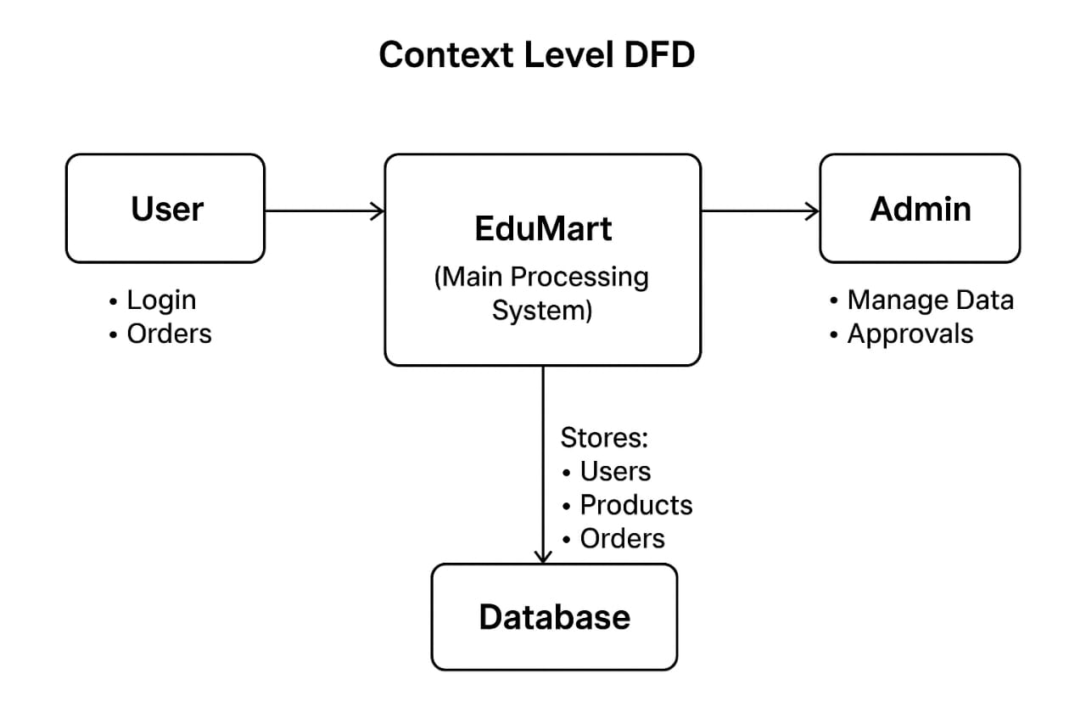

3. Functional Requirements
3.1 User Module
FR-01: User Registration
Users must create an account using email, name, and password.
System must validate duplicate accounts.
FR-02: User Login
Must authenticate with secure password encryption.
Incorrect attempts should generate error messages.
FR-03: Product Browsing
Users can view all available products along with images, prices, and descriptions.
FR-04: Product Search
Search bar should allow keyword-based product filtering.
FR-05: Add to Cart
Users can select items and store them in a temporary cart.
FR-06: Checkout
System generates a summary, calculates total, and simulates order placement.
FR-07: Order History
Users can track all past purchases with dates and statuses.
FR-08: Profile Management
Users can update name, contact information, and password.
FR-09: Product Upload
Users can list products with details, images, and pricing.
3.2 Admin Module
FR-10: Admin Login
Only authorized admins can access admin dashboard.
FR-11: Product Management
Admin can add, edit, delete, or approve product listings.
FR-12: User Management
Admin can view, block, or remove users violating policies.
FR-13: Order Monitoring
Admin can check all orders placed by users.
FR-14: System Logs
Admin can monitor internal activities for security purposes.

4. Non-Functional Requirements
4.1 Performance Requirements
Website should load within 3 seconds on average.
System must support at least 100 concurrent users.
Database queries should be optimized for large collections.

4.2 Security Requirements
Passwords must be hashed using encryption algorithms.
Admin panel protected with role-based access control.
Input validation required to prevent SQL/NoSQL injection.
HTTPS recommended for secure communication.

4.3 Usability Requirements
Interface must be clean, simple, and mobile-responsive.
Navigation must be intuitive for non-technical users.
All pages follow consistent design guidelines.

4.4 Reliability
System must ensure data consistency even during crashes.
Downtime should be minimized.
Backup should run weekly.

4.5 Maintainability
Code should be modular and reusable.
System should allow future upgrades without major redesign.

5. System Requirements
5.1 Hardware
Minimum 4GB RAM system
Any modern processor
Internet connection (5 Mbps or above)

5.2 Software
Windows/Linux/Mac OS
Browser (Chrome recommended)
MongoDB Community/Atlas
Node.js LTS
VS Code

6. Technology Stack
Layer Technology
Frontend HTML, CSS, React.js, JavaScript
Backend Node.js, Express.js
Database MongoDB
Development Tools Git, VS Code, Postman

7. Use Case Descriptions
Use Case: User Login
Actor: User
Precondition: User must be registered
Main flow: User enters credentials → system verifies → dashboard opens
Post-condition: User session created

Use Case: Add Product
Actor: Student/Teacher
Steps: Upload item → set price → submit → admin reviews

Use Case: Checkout
Actor: User
Steps: Select items → confirm address → simulate payment → order placed

Use Case: Admin Dashboard
Actor: Admin
Steps: Login → product/user/order managemen

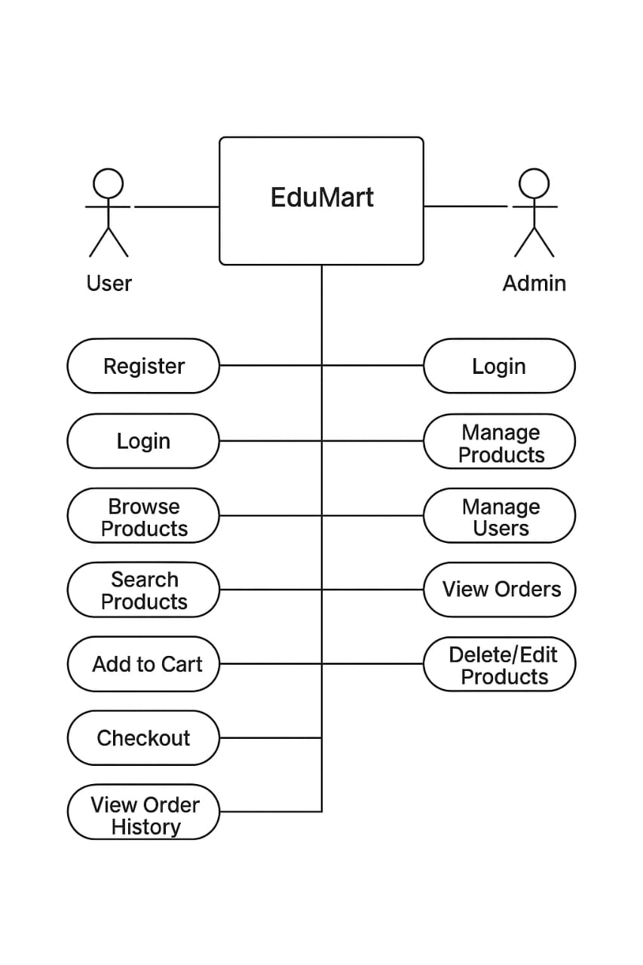
8. Future Enhancements
Real online payment integration
AI-based product recommendation
Mobile app (Android + iOS)
Delivery tracking
Live chat support
Seller rating and buyer feedback
Push notifications
Cloud backup automation

9. Conclusion
EduMart represents a modern, scalable, and student-centric digital marketplace.
This SRS ensures that every requirement is clearly defined so that developers can build the system accurately and efficiently. The document supports future enhancements and provides a strong foundation for academic and professional implementation.

